Ideation Phase
Empathize & Discover

Date
Team ID
Project Name
Maximum Marks | 4 Marks

Empathy Map Canvas:
An empathy map helps us understand the needs, thoughts, feelings, and challenges of the people who use the HouseRent Management System, such as tenants, property owners, and administrators. It gives the project team a clear understanding of what users expect from the platform and the problems they face during the house rental process.
By creating an empathy map, we can view the system from the user's perspective. This helps us design a simple, secure, and user-friendly rental platform that makes it easier to search for rental properties, manage listings, book houses, and communicate with property owners. Understanding the users' goals, expectations, and difficulties allows us to build a solution that improves their overall rental experience and meets their real needs.
Example:
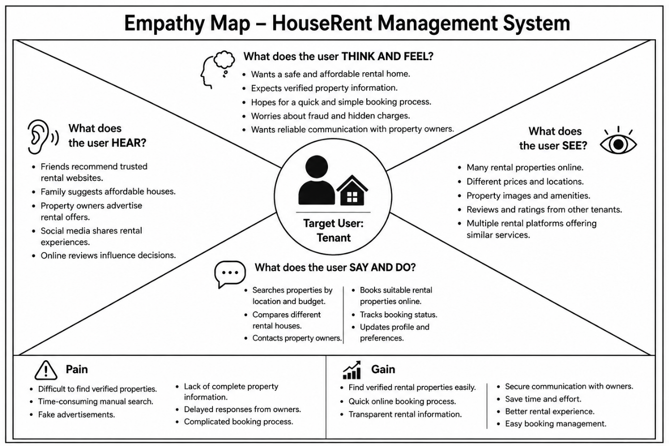

Example: Empathy Map – HouseRent Management System Web Application
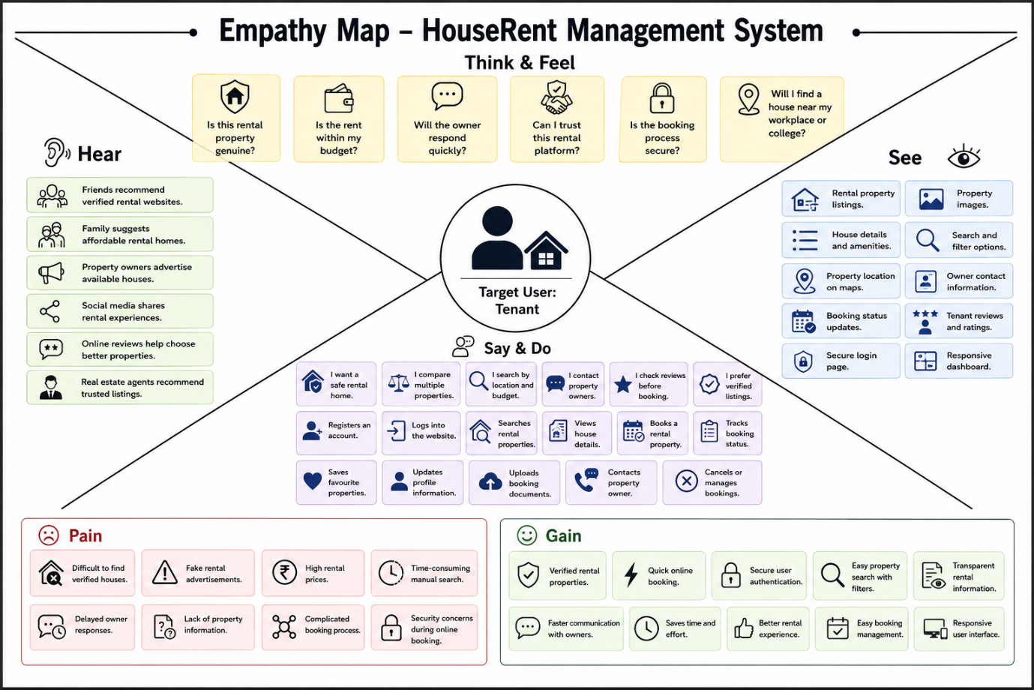

Reference: https://www.mural.co/templates/empathy-map-canvas

